Instructions at start

- Open python
- Tell python where your “base” or “start point is. Where the “command” is going to originate from. It will automatically start at PS C:\Users\user>
- You should change this for ease by using “cd” and then where you want the base to be.
The full command would usually be:
cd C:\Users\user\OneDrive\Documents\Business\BurdySetUp

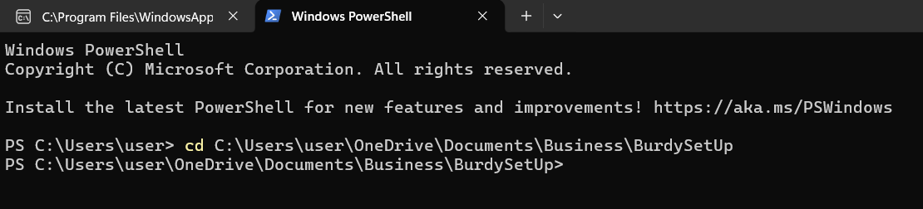

To view your programs
- Pick any .py program that is in that folder which is your base and write the command python -m streamlit run “xxxxxxx.py”
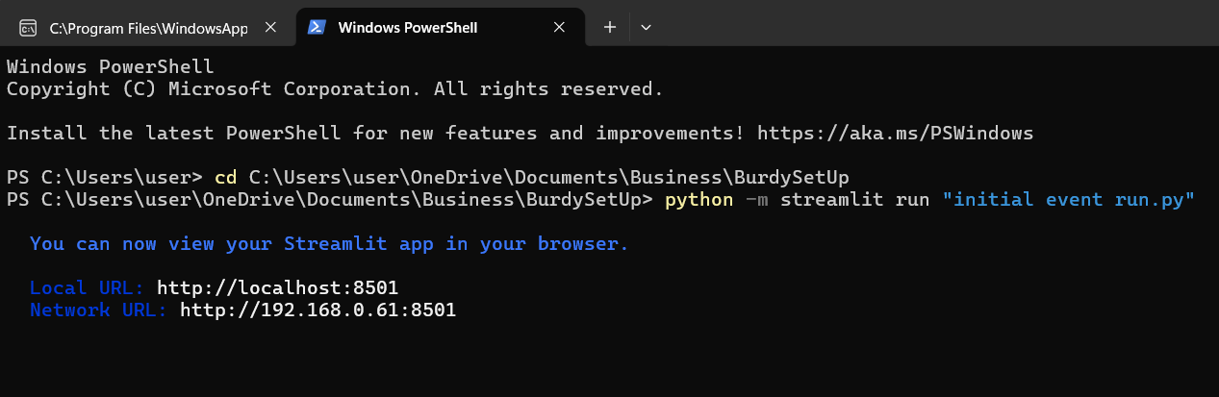
That will open a local non internet version of the program for you to check. This is not online for people to see.

